Front End Engineering-II

Project Proposal Semester-III (Batch-2023)

Educational Tour Guide

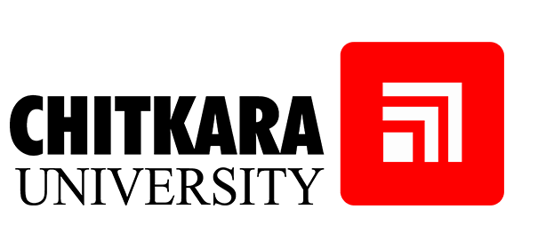

**Department of Computer Science and Engineering**

**Chitkara University Institute of Engineering & Technology, Chitkara University, Punjab**

**Supervised By: Submitted By:**

# Tapalagna Chakraborty 2310991694 (Ansh Jolly) 2310991703 (Arjit Pandey)

2310991704 (Armaan Singh Thind)

# 2310991705 (Krishna Saxena)

**PROJECT TITLE:** Educational Tour Guide.

**WEBSITE NAME:** EduVentures

**DESCRIPTION:**

Learn about global cultures and history with EduVentures. Our expertly curated educational tours offer unforgettable experiences for students and people of all ages. Discover ancient civilizations, explore vibrant cities, and connect with local communities. Help us help you explore the world through learning!

**TECHNOLOGY USED:** HTML, CSS, JavaScript, Bootstrap

## KEY FEATURES:

## Students Review and Ratings: A section where students can leave feedback and rate their experience.

## Event Calendar: A calendar for upcoming educational event, workshops or special tours. Keep students informed about additional learning opportunities.

## Booking and Reservation System.

## Virtual Tours: 360-degree views, and photo galleries of the tour destinations.

## Resource Library: Access educational resources and study materials to complement the tour experience.

## TARGET AUDIENCE:

## Target audience includes educators, parents, and students, offering tailored educational materials, interactive tools, and engaging content to enhance the learning experience for all age groups.

**MARKET COMPETITORS:**

|  |  |  |
| --- | --- | --- |
| **Competitor** | **Competitor Focus** | **Difference** |
| Field Trip Factory | This site provides free field trip experiences for educators and students. | - Comprehensive Booking System.  - Interactive learning resources  - Virtual tours. |
| Google Arts & Culture | Digital platform offering virtual tours of museums, art galleries, and cultural sites worldwide. | - Physical Tours.  - Interactive learning resources for student engagement during physical tours. |
| TourRadar | - Online travel agency for booking multi-day tours and guided vacations. | - Targets educational tours rather than general travel.  - Student Reviews and Ratings. |
| TourBuddy | Mobile app providing audio guides and self-guided tour solutions | - Booking and reservation system.  - Interactive learning resources. |
| Discovery Education | Digital educational content and resources for schools. | - Physical Travel.  - Itineraries. |

**LOGO:**

